Linux Bash Files
Dan Richter
14 Sep 2020

In this article, we going to go a little more in-depth on bash script files. If any of you have taken any programming classes, you know the first program you write is the Hello World, right? Well, let’s start with that in the lesson.

Now, it really wouldn’t be to difficult to type in ‘echo Hello World’, but where would the fun be in that.
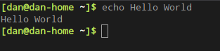
So, let’s start with our script file, we will call ‘hello.sh’. We’ll add the shebang right away.
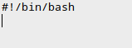
And we’ll start with the simple echo command.
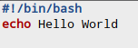
We can then run ‘chmod +x hello.sh’ and run our script.
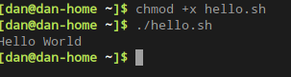
That was fun, wasn’t it? :) Let’s make this a little more challenging. We’ll introduce variables into this script. If you have done programming before, you know that in most languages you have to indicate what the variable will be used for. For example, in C, you would declare your variable as ‘int counter=0’, or ‘char name[15]’. Well, in bash, you don’t have to. Just indicate the name of the variable, and what you would like it to hold.
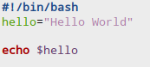
In this case, we’ve created a variable called ‘hello’, and assigned it the value of ‘Hello World’. Then, instead of typing in ‘echo Hello World’, we now just have to call the variable, and ‘echo $hello’. The dollar sign tells bash to convert ‘hello’ into what is stored in that location.
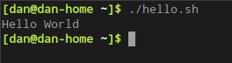
Let’s make this a little more interesting. One of the things that you can do with bash, is utilize other programs within Linux, to capture information. For example, from a terminal window, you can type in ‘date’ and you will get the current date and time. Using this within bash can give you a lot of flexibility in your scripts. If you are trying to scrape a web site’s news articles, but only want ones that were posted today, you would use this functionality.
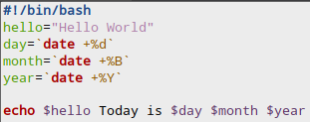
Here is what I’ve added to our script. There is now a variable for day, month and year. When we set up these variables, we need to use the ` symbol, which is located above the <tab> key, at least on my keyboards… What this symbol does, is tell bash to run this command, and put the output of the command into the variable. So, bash sees this and runs ‘date +%d’, and stores the output of ‘14’ into the variable named ‘day’.

When we get to our echo line in the script, we use those variables the same as we did with ‘hello’. The ‘$’ tells bash to display what is being held in this variable.

Using this, we can customize our output to the screen.

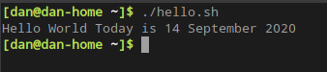
Now this is getting fun. :)

How about we go one step further with this.

I’ve added a few lines to our script. Take a look at it and see if you can figure out what will happen when we run this one.

Don’t cheat! :)
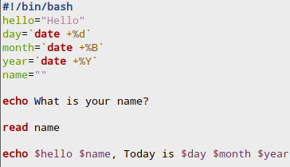
First, I changed the contents of ‘hello’, to just ‘Hello’.

Secondly, I added another variable called name, but didn’t assign anything to it.

Then, I echoed ‘What is your name?’ to the screen.

The ‘read name’ will actually take input from the user. Once they type in their name and hit <enter>, their name will be stored in the variable ‘name’.

The last line echos to the screen using the user’s name.
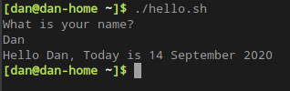
Now, for our last exercise for this article, let’s add some more to our script.

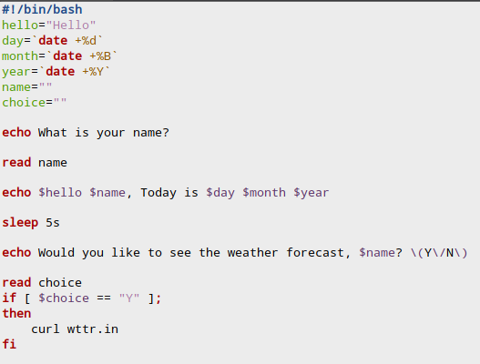
Ok, this will take a little explaining. I added another variable, called choice, again it isn’t holding any information yet.

I have then added a ‘sleep’ line, which will wait 5 seconds before moving on in the script.

Then there is another question asked of the user, that asks if they would like to see the weather forecast.

The read choice will take in the users answer.

The if line checks to see if the users choice equals ‘Y’.

If the answer was ‘Y’, the ‘then’ line will execute, which is the ‘curl wttr.in’. Curl is a way to grab something from the internet from the command line. We’ll have an article on that in the future.

The ‘fi’ closes the ‘if’ conditional. Notice it’s ‘if’ spelled backwards. :)

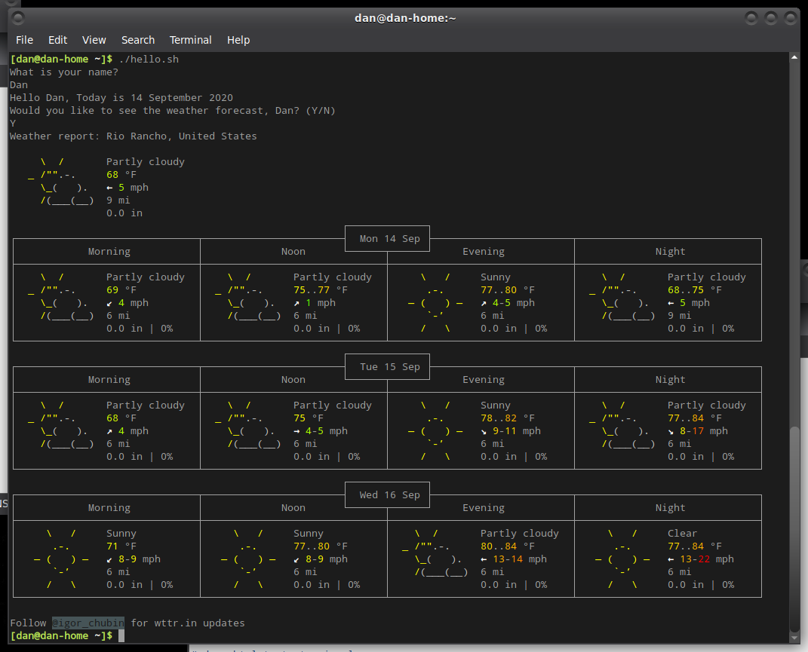
That was probably a little further than I had intended to go in this article, but I thought it was fun. We’ll go further into bash scripting in future articles.

